*Revised for Context 21 October 2003*

Chapter 1*

RAMP-TRIM Users Manual
[Records Archives Management Program-Total Records Information Management]

Overview

RAMP-TRIM and

Organization Work Units

United Nations Children’s Fund
3 United Nations Plaza
New York, New York 10017

Chapter 1. Overview RAMP-TRIM
and
Organization Work Units

Table of Contents

1.1 Introduction 4
1.1.1 Records Lifecycle 4
1.1.2 Training Component - Courses Available 4
1.1.3 RAMP Design and Future Modules 4
1.1.4 Originator of Records - Organization Tree 5
1.1.5 Management Briefing Questions 5
1.2 TRIM Overview Error! Bookmark not defined.
1.2.1 Records 5
1.2.2 Basic Searches in RAMP-TRIM 6
1.2.3 How to Locate an Organization Work Unit 11
1.2.4 Saved Searches 16
1.2.5 Help File 17
1.2.6 Record View and Record List Pane 18
1.3 Overview Exercise 19
1.3.1 Organization Tree - Fill in Division and Section. 19
1.3.2 Display a Work Unit. 19
1.4 Key Learning Points & Charts Used in Presentation. 20
1.4.2 RAMP-TRIM Design. 20
1.5 Self-Test. 21
1.5.1 Questions for RAMP-TRIM Introduction and Overview. 21
1.5.2 Questions and Answers. 22

List of Figures

Figue 1 Error! Bookmark not defined.

Figure 1. Menu selections Search and Find Error! Bookmark not defined.
Figure 2. Basic Search Panel 7
Figure 5. Dropdown 10
Figure 6. Kwikselect Option 10
Figure 7. Hierarchical List of Search Fields 11
Figure 8. Searching with Partial Words 14
Figure 9. List of all Records starring with "Rur" 15
Figure 10. Top of the Locations Table Error! Bookmark not defined.
Figure 11. Typical Hierarchical Locations List after being opened using the + characters 12
Figure 12. Locations Search Panel 13
Figure 13. Partial Saved Search Screen 16
Figure 14. Help Screen Error! Bookmark not defined.
Figure 15. Record View Pane & Record List Pane 18

1.1 Introduction

1.1.1 Records Lifecycle

Narrative from Presentation:
Request, Receive, Create
Log (Register), Assign, Route, Track
Cross Reference, File, Retrieve for Reuse
Pack, Transfer off Site, Retrieve for Reuse
- Appraise, Identify Long term retention

Parking Lot Issues Related to RAMP-TRIM and Record Life Cycle
Disposal: Alternate Media/Destruction
See Intro PowerPoint Presentation list and
- Participants concerns – “Parking Lot”

1.1.2 Training Component - Courses Available
Fundamentals

Overview - Organization Tree & Work Unit
Record Series Inventory

Intermediate

File Folder Listing
Shipment/Transfer - Box/Container

For additional information See RAMP Training Modules chart Annex E

1.1.3 RAMP Design and Future Modules

Narrative from Presentation:

See Table of contents guide to RAMP-TRIM

1.1.4 Originator of Records - Organization Tree
- Directory of Work Units
- Originator versus Owner of Records
- Owner, Home and Current Location
- UNICEF ownership of Records
- Preliminary Appraisal by Work Units
- Final Appraisal by RAM & UN Archives [Appraisal Grid
- See also Annex G for Policy and Procedure guidelines list

See Organization Tree Exercise 1.3 on pages 1-14 and 1-15

1.1.5 Management Briefing Questions

Narrative from Management Briefing for Divisions arranged with RAM Unit.

See Management Briefings on Annex F.

1.2 TRIM Overview

    - Records

TRIM manages Records. A record can be anything. The most common kinds of records are Files and Documents, however there is nothing stopping you registering magazines, boxes, CDs, books, even your collection of shoes and thus they are also records.

When RAMP-TRIM is installed, you must select the “series”, “folders”, “items” or any other Record Type. You have to tell RAMP-TRIM what sort of records you have and what information they are to contain.

This is what Record Types are all about. RAMP-TRIM can reflect the different types of records that may occur within your organization, but first you must select the appropriate Record Type.

1.2.2 Basic Searches in RAMP-TRIM

You can conduct different searches on the RAMP-TRIM data. The kind of search conducted will depend upon what you know about the record. For example, you might search for words occurring in the title or notes field, or you might only know that the record belongs to a unit, department or individual in which case you will search for records owned by them. To illustrate searching for records owned by a business unit do the following:

- Navigate the menu selection Search and Find Records...

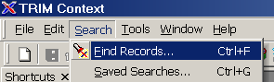

Figure 1. Menu selections Search and Find

- This selection will launch the basic Search screen. Observe the screen structure. The field titled “Search By” identifies the field that will be searched. The field below, titled “Equal To” in this example [this title changes when the Search By value is changed], shows the value or text that will be located. We will return to these values in step 3, but first examine the elements of the tabs: Search, Sort and Filter.

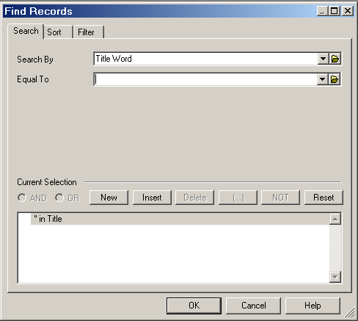
Figure 2. Basic Search Panel

Filter ► Record Type A number of different Record Types are available and you may search all record types or narrow your search to a specific record type. Always select the Filter tab and check the Record Types selection and assure that you are searching for the proper record type. Consider narrowing the search to fewer or a single Record Type. This search strategy may reduce the total volume of records returned in your search. To select a particular record type:

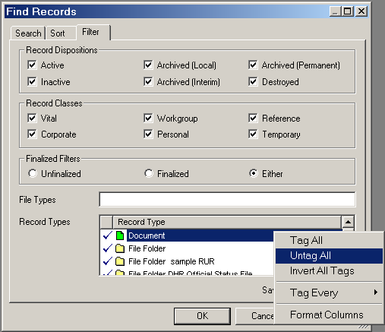
Figure 3. Searching and using the Filter tab to narrow down Record Type

- Position the mouse pointer in the Record Type field
- Right-click within the field to open a smaller dialog box
- Select “Untag All”
- Scroll to find the record type you wish to choose
- Position the mouse pointer next to the desired record type and click the mouse to add a check mark

The Filter options permit filtering out select Disposition and Class settings. Generally, the default setting will be adequate.

Sort The search results may be sorted in a specific order by setting the sort sequence. Employ this optional feature by clicking on the Sort tab and entering the desired sort method in the Sort Fields. A list of available sort methods are found in the drop-down list.

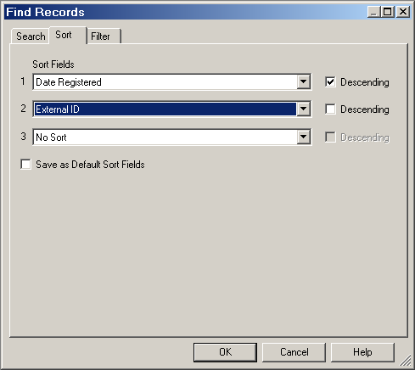
Figure 4. Searching and sorting the results

Advanced Search An advanced search permits you to combine multiple search parameters using Boolean operators and may result in greater precision. Consult Annex B for a description of Advanced Search procedures. Generally, the default setting will be adequate. Advanced users may wish to consult the RAMP-TRIM Administrator for information on employing the filter features.

- Searching When beginning a search you are presented with the screen displayed in Figure2. The most frequently used search criteria are displayed in the drop-down box.

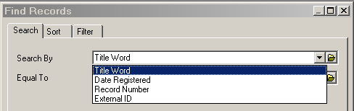
Drop-down box tool
Figure 5. Drop-down tool

If the desired search field is presented in the list, select it and enter the search value in the field directly beneath it. However, if you would like to search using another field characteristic you will use the Kwikselect option, which is accessed using the folder icon adjacent to the drop-down.

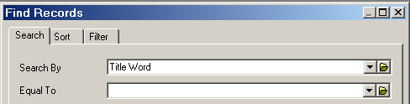
Kwikselect Search Option
Figure 6. Kwikselect Option

When Kwikselect is chosen a list of all fields is presented from which you may select a field. Examine this hierarchical list and drill down the list by simply clicking the cursor on the plus sign.

1.2.3 How to Locate an Organization Work Unit

For this example navigate down the list (use the + to open the list) from Locations to the field titled Location and then select Owner Location. Select OK to move the value Owner Location into the Search By field.

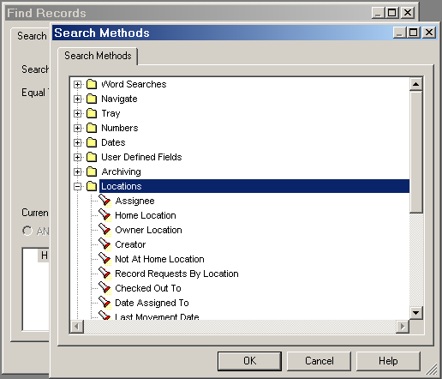
Figure 7. Hierarchical List of Search Fields

The Search value field may be populated by one of three methods. A) Once you are familiar with the search values you can enter the search value exactly as it is presented in the [Hierarchical List of Search Fields]. B), You can also enter the first part of the phrase and click on the Kwikselect button to look up and select from the relevant options, and C) search all citations via the Organization Tree.

There are a number of ways to locate an Organization Work Unit after logging on to RAMP TRIM.

Use the Organization Tree [Hierarchical]

Search without specifying a work unit. The Hierarchical list will be displayed. Navigate through various levels of the displayed organizational chart for progressively more specific information on City, Division, Section and Unit.

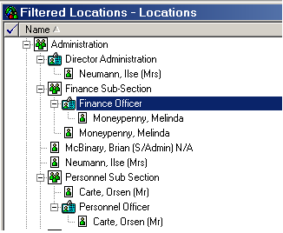
Figure 8. Typical Hierarchical Locations List after being opened using the + characters

Search for the parent Unit

Using either of the methods above locate the “parent” work unit and drill down to the work unit required. A “parent” work unit is the supervising authority.

Navigate down the hierarchical locations list and make a selection by highlighting the entry.

As an alternative, search the Locations list with the Search function. Click the Search button at the bottom of the Search pane (or by right-clicking in the hierarchical list window, selecting Search, then selecting in the sub-menu Refine Search).

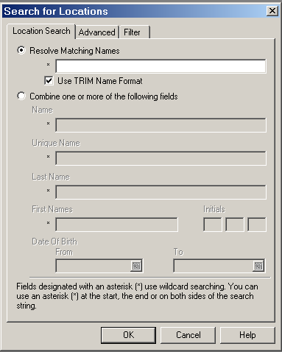
Figure 9. Locations Search Panel

Search for One work unit

Search for the unique Division, Section, or Work Unit by the first few letters of the work unit name.

 Enter an exact value in the Owner Locations Field, or…

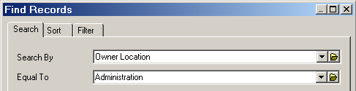
Figure 10.a. Searching with exact word values

 Enter partial value in the Owner Location field.

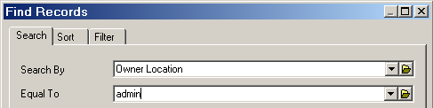
Figure 10.b. Searching with Partial Words

 Use the Kwikselect to display a list of all words beginning with the selected characters.

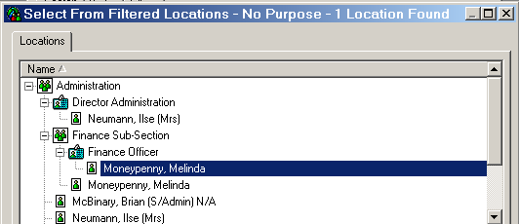
Figure 11. List of all Records under the prefix “admin”

- From this list of all owner locations beginning with the characters “admin” highlight the correct entry and select Ok to populate the Owner Locations field. Now select OK to conduct the search.

Finally, if you have no idea which location to enter, use the Kwikselect icon and navigate down to the locations hierarchy using the + character to move down the list. Alternately use the search function.

Locations

In RAMP-TRIM you will be introduced to the concept of 3 types of Locations:

Owner
Home
Current

Demonstration:
The following sections give a detailed screen-by-screen presentation.

Contacts:
In addition to identifying work unit locations for a record, it may be useful to identify one or more staff members as the Contact for a specific record or file. This will be demonstrated in the Series and folder RAMP-TRIM training modules.

Unit, Position, Staff
In some circumstances you may also be able to search by the Position [post title] or Staff [individual name]. This will be further demonstrated in the Folders RAMP-TRIM Training module.

1.2.4 Saved Searches

Some search criteria may be reused periodically. These search criteria can be saved using the Saved Search function. First construct a search for the word “rules.” With the search results displayed, navigate to the menu bar and select File and Save Search. You are presented with the search profile screen. Enter a Name and annotate the Description field as necessary. Select Ok to save the search. You may edit the query now or in the future through the Edit function. The Saved Search can be recalled and then executed anytime through the Search and Saved Search Functions or the fast path keys Ctrl-G.

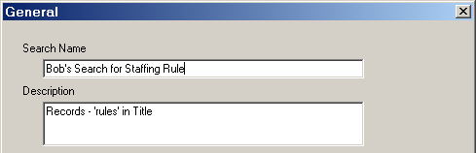
Figure 12. Partial Saved Search Screen

1.2.5 Help File

Search for more information concerning the application in the Help file. Access Help through the menu Help function or the fast path key combination Alt-H or Shift-F1. In the pane on the left of the screen you can search for a Help topic by typing in a keyword to find (Figure 14a), or you can select the Contents tab to reveal the contents of the Help Index (Figure 14b).

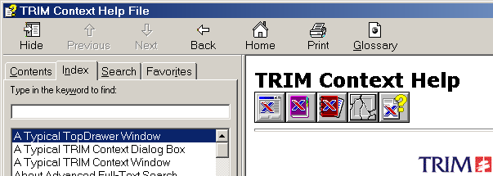

Figure 13.a. Help screen using search field

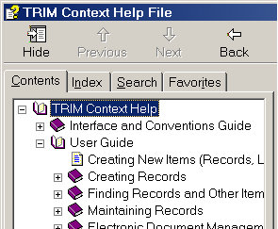
Figure 13.b. Help screen using Contents Index

1.2.6 Record View and Record List Panes

The RAMP-TRIM screen is divided into an upper list pane and lower view pane. The search results are shown in the view pane while details of the highlighted record are shown in the view pane.
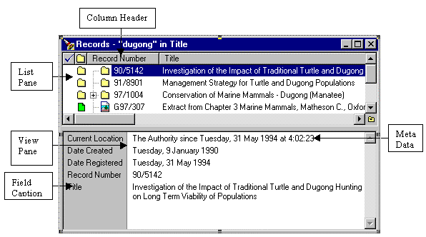
Figure 14. Record View Pane & Record List Pane

You can change the ascending/descending lists in the columns of the View Pane by clicking on the column titles. You can also design the order and appearance of columns by moving the cursor in the View Pane, right-clicking the mouse, and selecting Format Columns. You can then move fields to or from the Available Fields and Active Fields list, and then adjust the presentation sequence by arranging the order with the up and down functions.

You can change the order in which fields are presented in the View Pane by placing the cursor in the field, right clicking the mouse, selecting Customize, moving fields to or from the Available Fields and Active Fields list, and then arranging presentation sequence by arranging the order with the up and down functions.

1.3 Overview Exercise

1.3.1 Organization Tree - Fill in Division and Section.
 | 1 | 2 | 3 | 4 | 5
Org Levels |  |  |  | Complete | Fill in your Div/Sect
Organizations | United  Nations | UNICEF | UNDP | UNICEF | UNICEF
Organization  Abbreviation | UN | CF= | DP = | CF | CF=
City | Colombia | New York | Ruratania | Ruratania | New York
City Abbreviation | Cola | USAA | Rur(a)
UN Department |  | Operations
Division / Office | Supply | DFAM | Programme
Section |  | Admin  Services | Health
Unit |  | Head-  quarters
Sub Unit |  | Docs &  Repro
Function

1.3.2 Display a Work Unit

Orgs | Org  Abrev | City | City  Abrev | [UN  Department] | Division /  Office | Section | Unit
UNICEF | CF= | New  York | USAA | [Operations] | DFAM | Admin  Services | Head-  quarter
UNICEF | CF= | New  York
UNICEF | CF= | New  York
Information on specific Work Unit records:

- Record Series _____________________
- File Folders ______________________
- Boxes ______________________
- Shipments _____________________

1.4 Key Learning Points & Charts Used in Presentation.

1.4.2 RAMP-TRIM Design.

 |  |  |  |  | Work Unit
 |  |  |  | Record Series
 |  | List File Folders |  |  |  |  |  | List Boxes
 |  |  |  |  |  |  |  |  |  |  |  |  | Accessions
List File Items |  |  |  |  |  |  |  |  |  |  | Transfer Shipments

1.5 Self-Test.

1.5.1 Questions for RAMP-TRIM Introduction and Overview.

Q. What three ways are possible to find your work unit?
[If you do not know the full exact wording for the work unit]

A. 1)

2)

3)

Q. What is the difference between a records work unit and the series of records?

A. 1) The work unit is
2) Series are

Q. What is the difference between the various “Locations” for a record?

A. 1) The Owner Location is ____________________________________
2) The Home Location is _____________________________________
3) The Current Location is____________________________________

1.5.2 Questions and Answers.

Q. What three ways are possible to find your Division, Section or work unit?

A. 1) Search for Locations, via Hierarchy and drill down through the Organization Tree;
2) Search for the Division, Section or Unit by first letters of title
3) Search for a Parent unit and then use plus sign to drill down.
[If you know the exact wording of the work unit, you can go directly to it]

Q. What is the difference between the Location Work Unit and the Series of Records?

A. 1) The Work Unit is the unit that originated or owns the records or the "Who" of the records.

2) Series are the "What" of the records, what types of records, what groups of records or what cluster of records.

Q. What is the difference between the various “Locations” for a record?

A. 1) The Owner Location in RAMP-TRIM is usually the Division that the work unit creating the record reports to.
2) The Home Location is usually the work unit, which maintains the record until it is sent to a storage location.
3) The Current Location is where the record is now located. If t is borrowed it is returned to the Home location or sent temporarily to another “current” location.

Q. What is the most common mistake entering the RAMP-TRIM database?

A. 1) The Caps lock is on for the user id or password.

